Part A

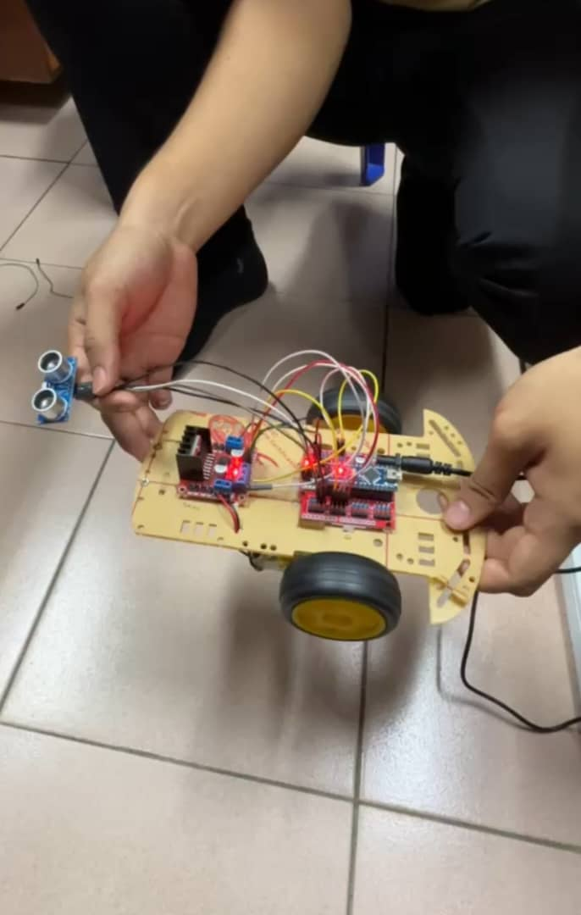

When the distance is exceed than 19 cm:

* If the sensor detects that the distances to an obstacle is greater than 19cm, it assumes the path is clear.
* The action will be the both motors are set to move forward (fwdright7 and fwdleft5) in HIGH condition and allowing the robot to continue moving forward

When the distance is less than 18 cm:

* The robot stops by turning off both motor in 500miliseconds. It is because the pins (fwdright7, revright6, fwdleft5, revleft4) are set to LOW.
* After stopping, the robot moves backward in 500 miliseconds. It is because (revright6 and revleft4) are set to HIGH so that can be both motors in reverse condition while for (fwdright7 and fwdleft5) are set to LOW, keeping forward condition deactivated so no action for that.
* After reversing, the robot stops again in 100 miliseconds. The final action of the motor before the loop ends is to make the robot **turn** by moving only the **right motor forward** for 500 milliseconds because is set (fwdright7) in HIGH condition, while the left motor stays still because (revright6, revleft4 and fwdleft5) in LOW condition. This causes the robot to change direction. After this, the loop restarts, and the robot checks for barrires again using the ultrasonic sensor. This process repeats, allowing the robot to keep moving and avoiding barriers based on the sensors measurements.

PART B

The ultrasonic sensor send out an ultrasonic pulse and wait for its echo to calculate the distance to an object . If the object is detected within 50 cm,

the servo rotates to 90 degrees . Otherwise, it will resets to 0 degrees.